2018 Marlin Swim Team Shirt
*T-shirts will be green and white tie-dye with black lettering
*All registered team members’ names will be displayed inside the 2018!
(Must be registered by May 26^{th.})
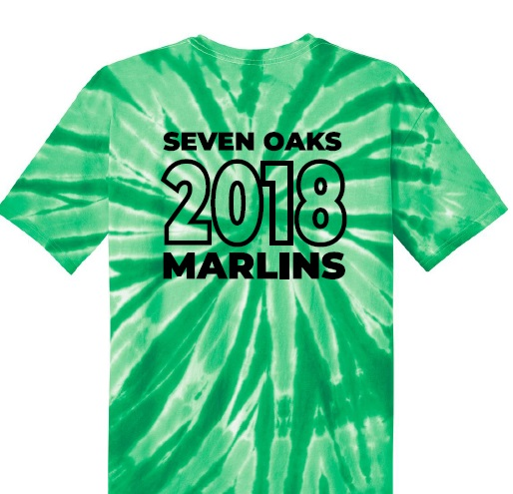
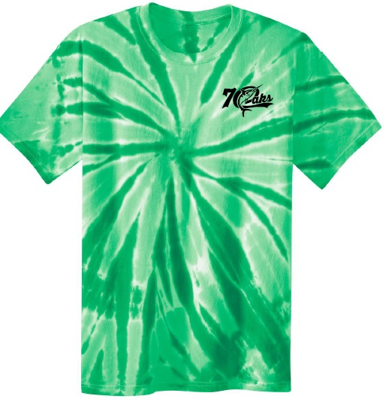
*Pre-Order ONLY! $25 each. (Separate check from registration. Orders DUE JUNE 1st.)

Swimmer(s) Name: ___________________________________________________________________________
Parent Name: _______________________________________________________________________________
Email address (write clearly, please!): ____________________________________________________________

YOUTH ADULT
Size Amount Size Amount
Youth XS ______ Adult S ______
Youth S ______ Adult M ______
Youth M ______ Adult L ______
Youth L ______ Adult XL ______
Youth XL ______ Adult XXL ______
Adult 3XL ______
Adult 4XL ______
Adult 5XL ______
T-shirts Ordered ______ X $25 = $________

