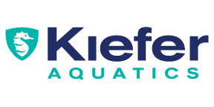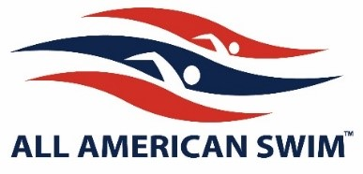
Summer 2023
How to get your team suit?
Seven Oaks Marlins Families
Come visit Kiefer Aquatics/All American Swim for all your summer swim needs.
Team Suit: Rise Solid with logo Female $41 Jammer $35
Goggles starting as low as $10
Practice suits, caps, and fun swim apparel.
2 ways to get your team suit
- Come to the store to get the perfect fit
- Call to place a phone order and pay for shipping to your home

1231 NW Maynard Rd Cary NC 27513 919-439-8678
Hours: Monday-Thursday 10a-6p and Saturday 10a-3p
Check our website for additional hours in May-June
Store Locations & Hours - Kiefer Aquatics

Team suits with logos – final sale

